**Tableau**

1. **Sales, Profit and Profit Margin by Channel And Time**

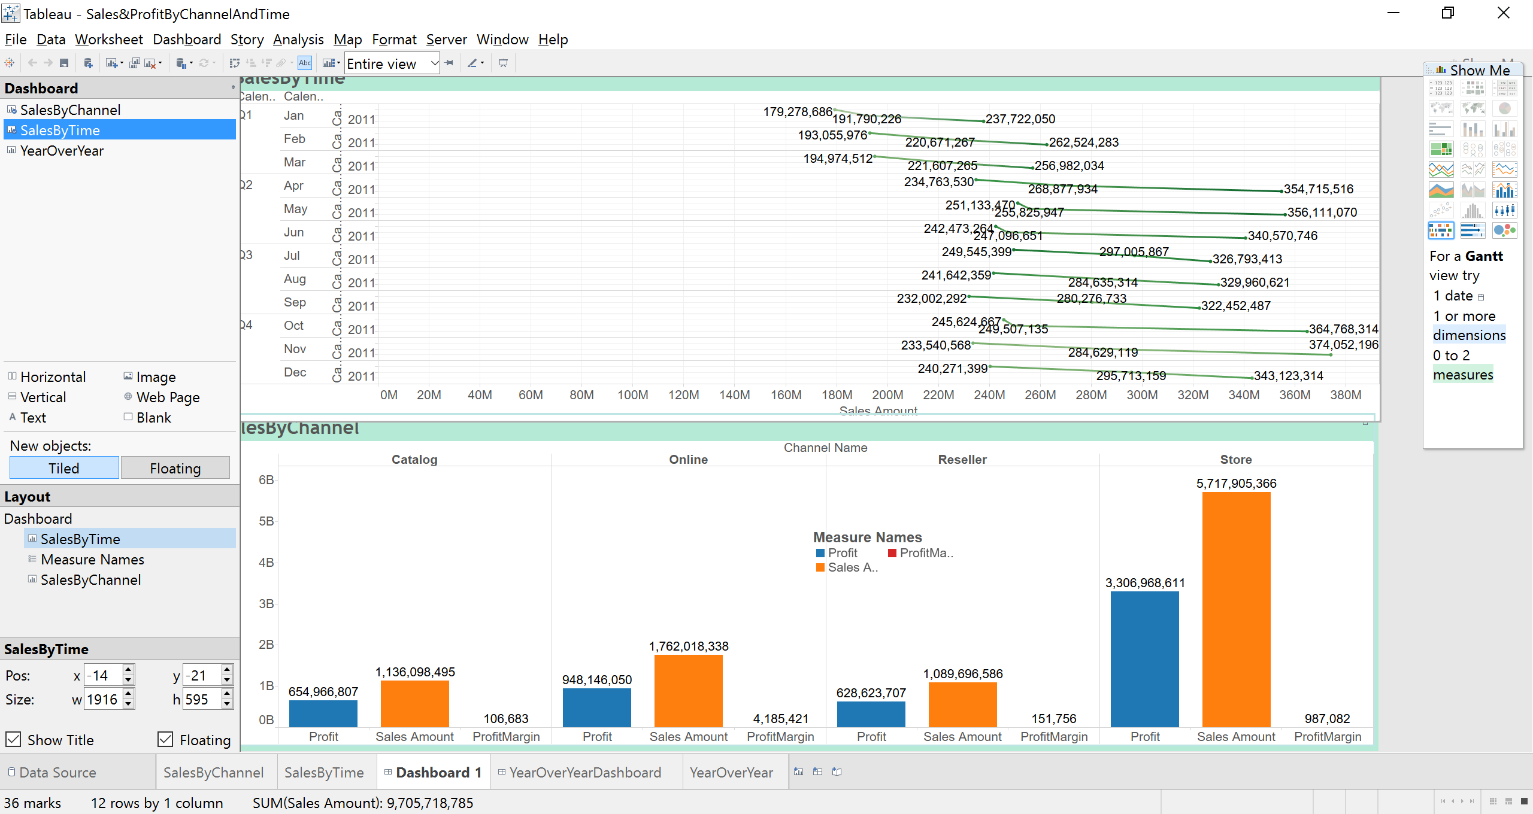

**Year over Year Analysis**

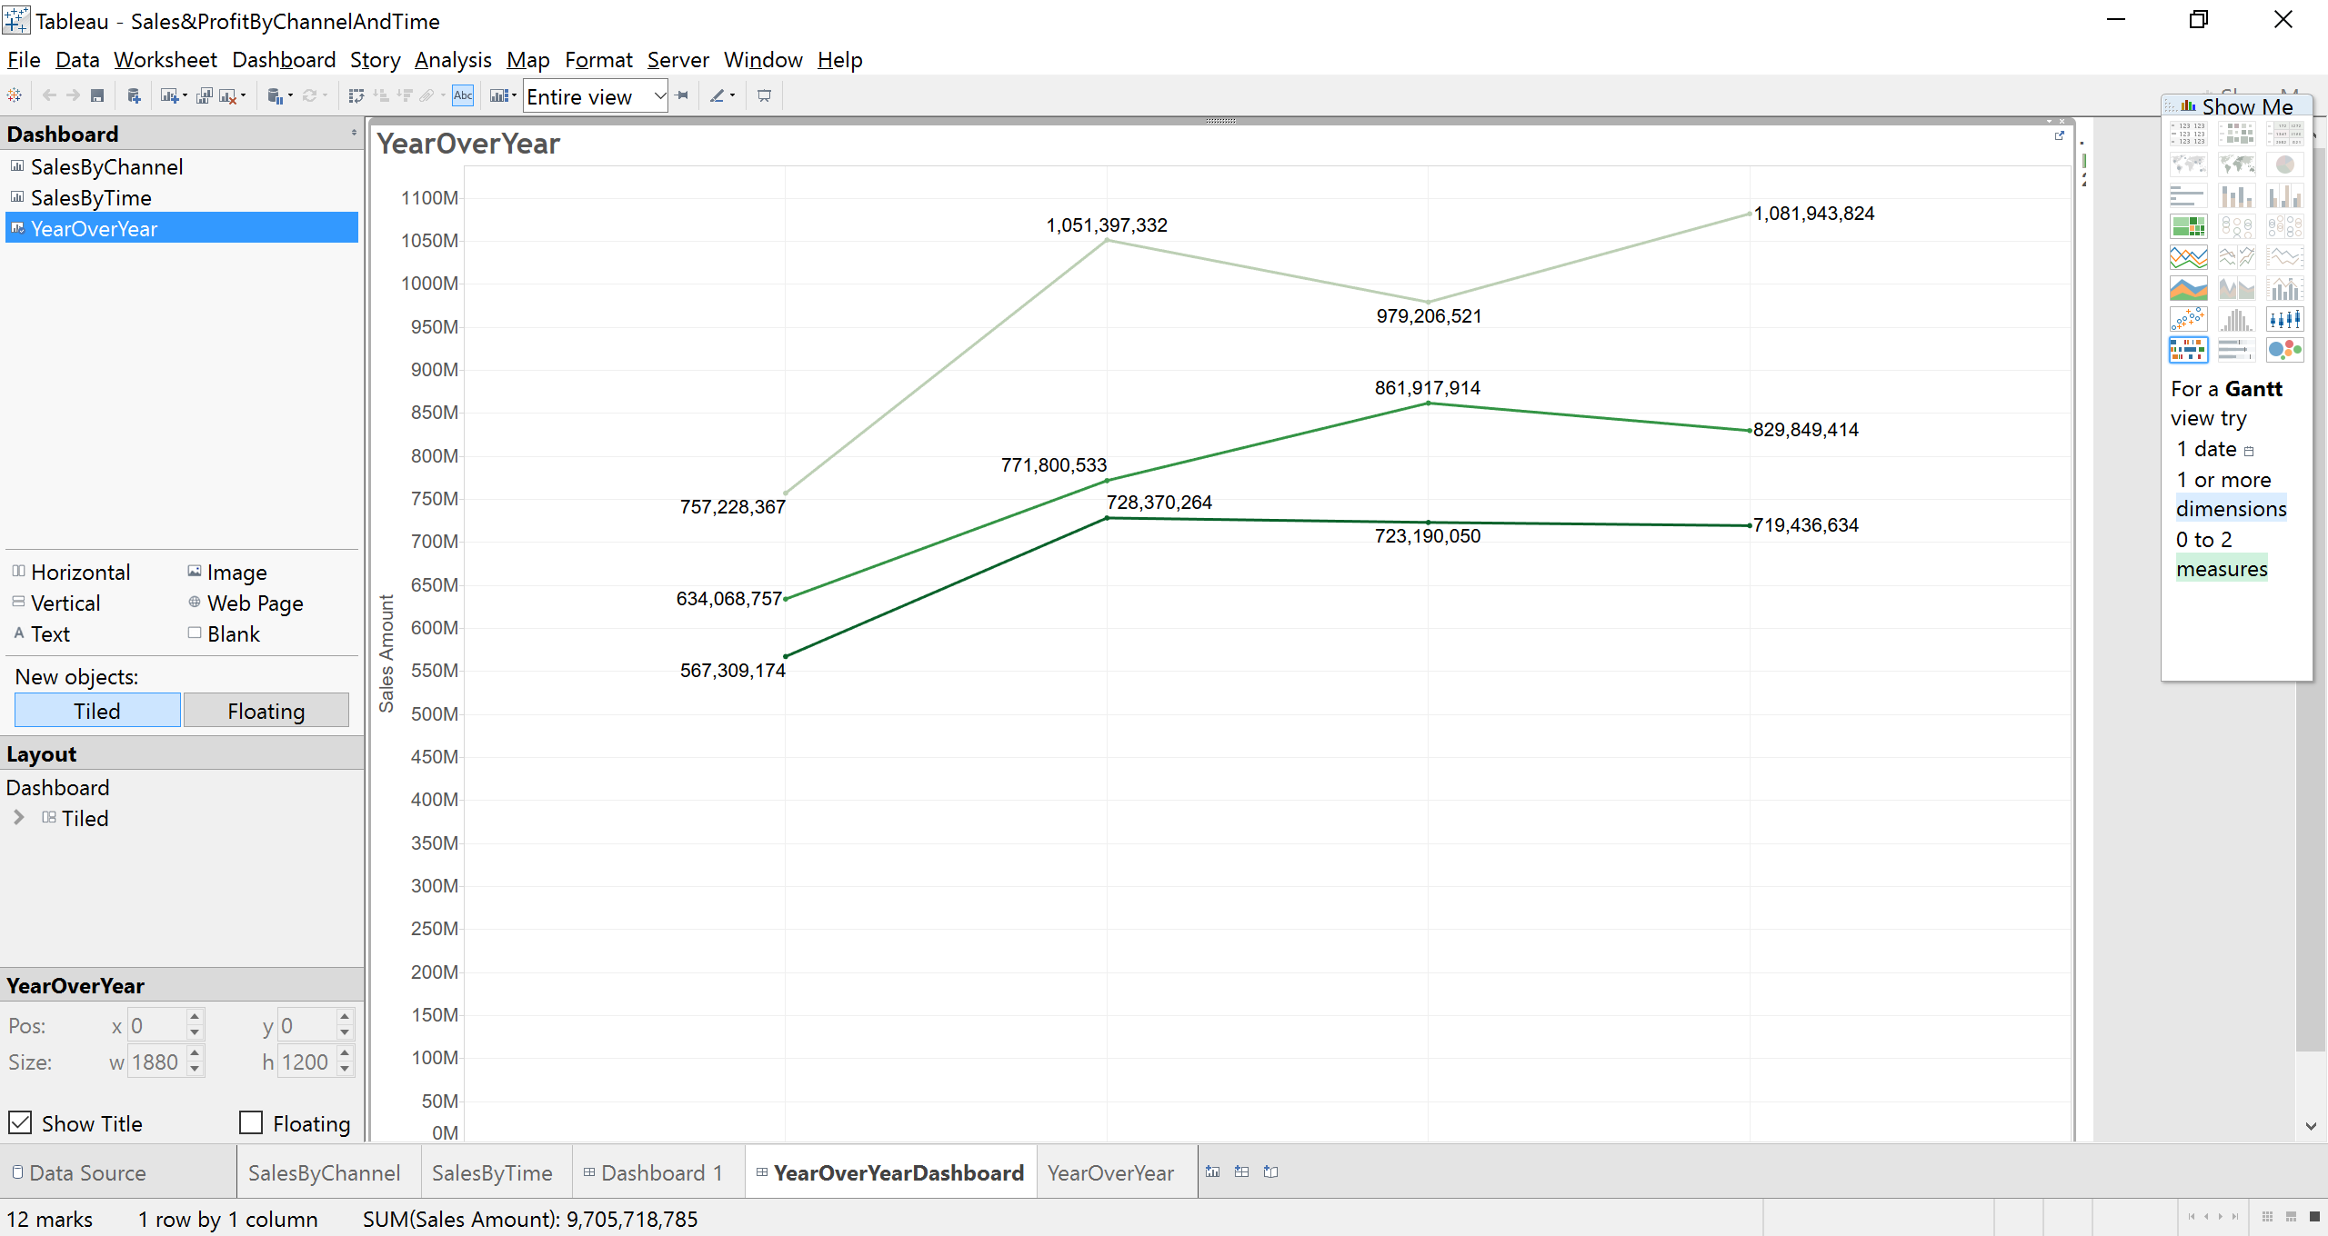

1. **Rank sales**

**By product Category and Subcategory**

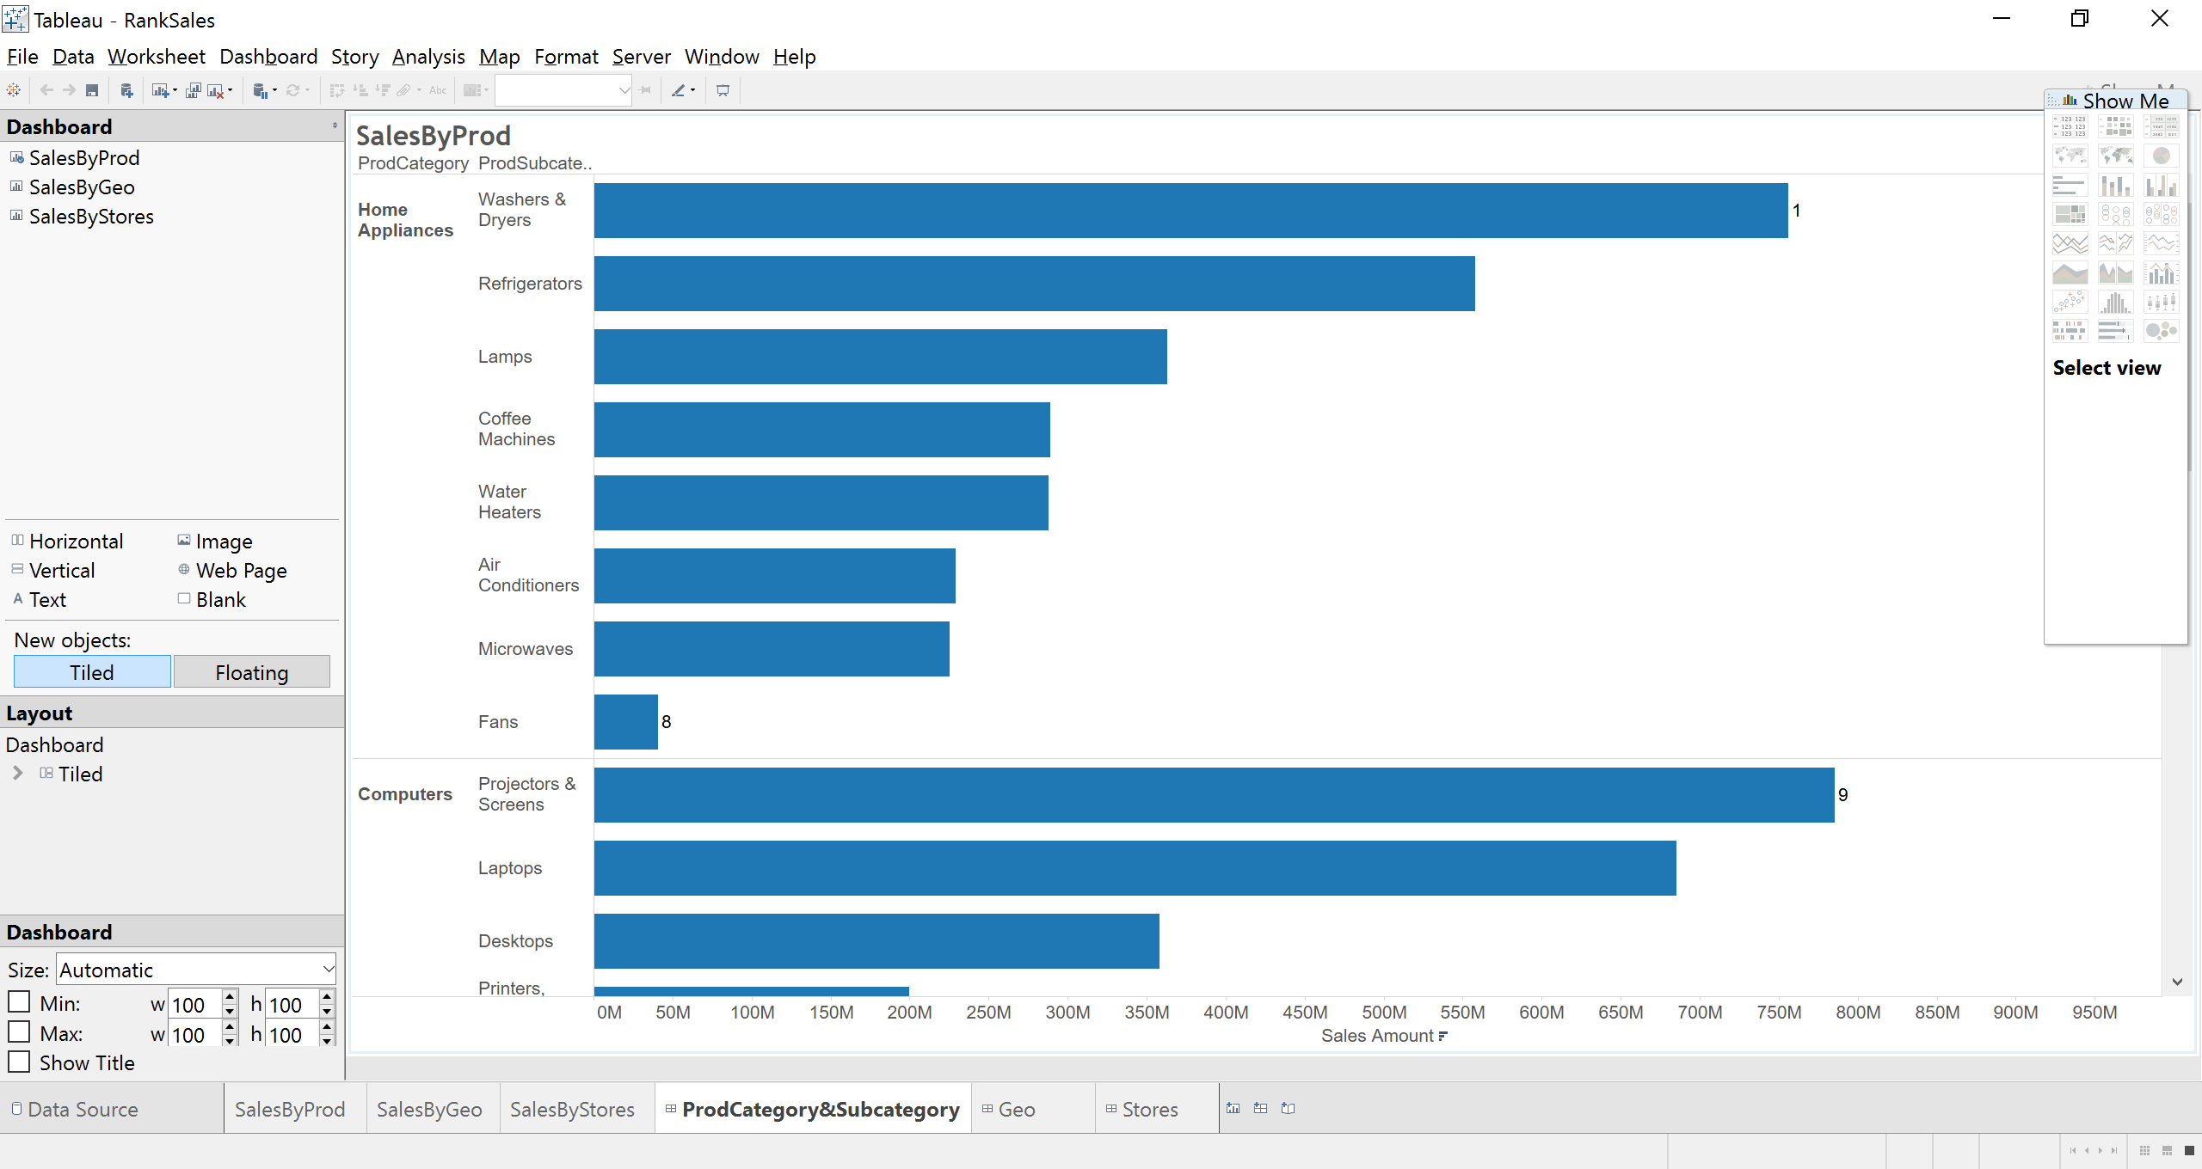

**By Country & State**

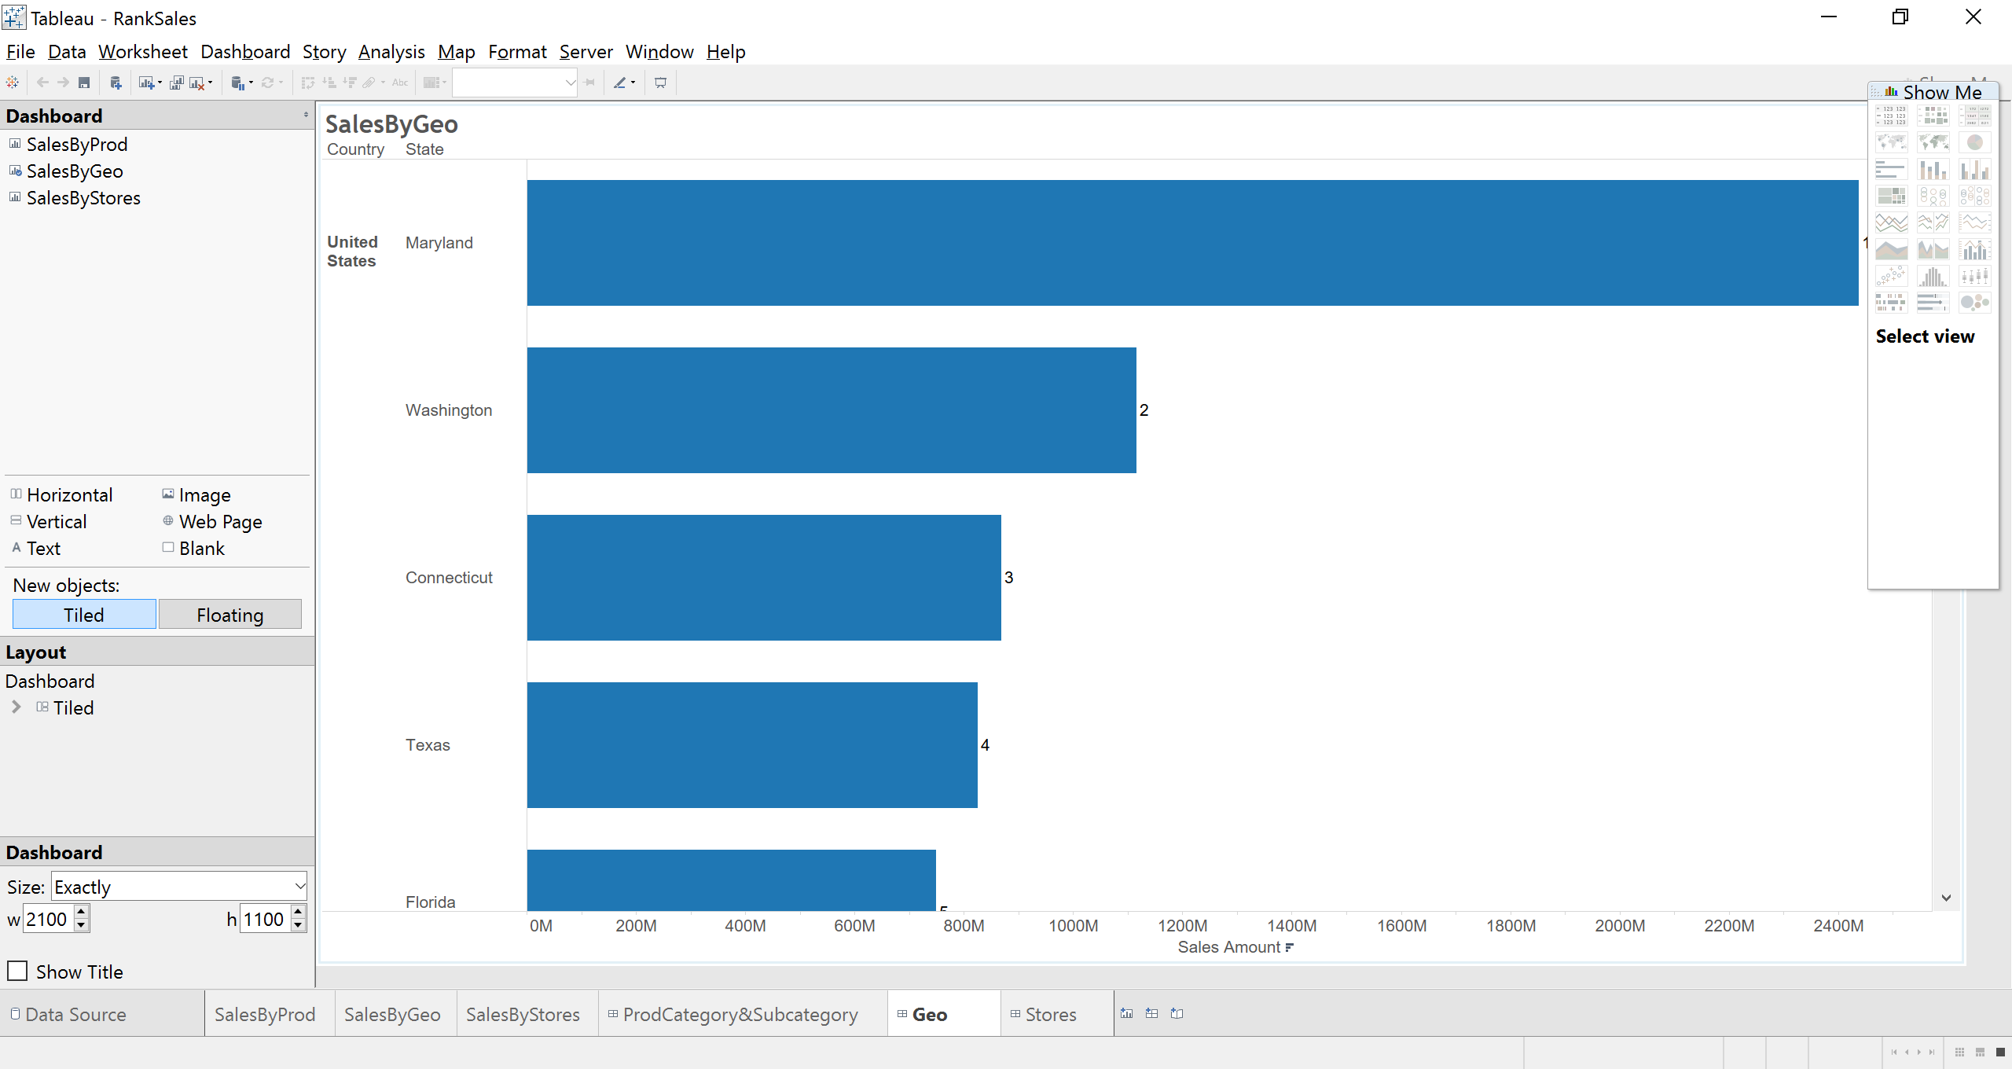

**By Store**

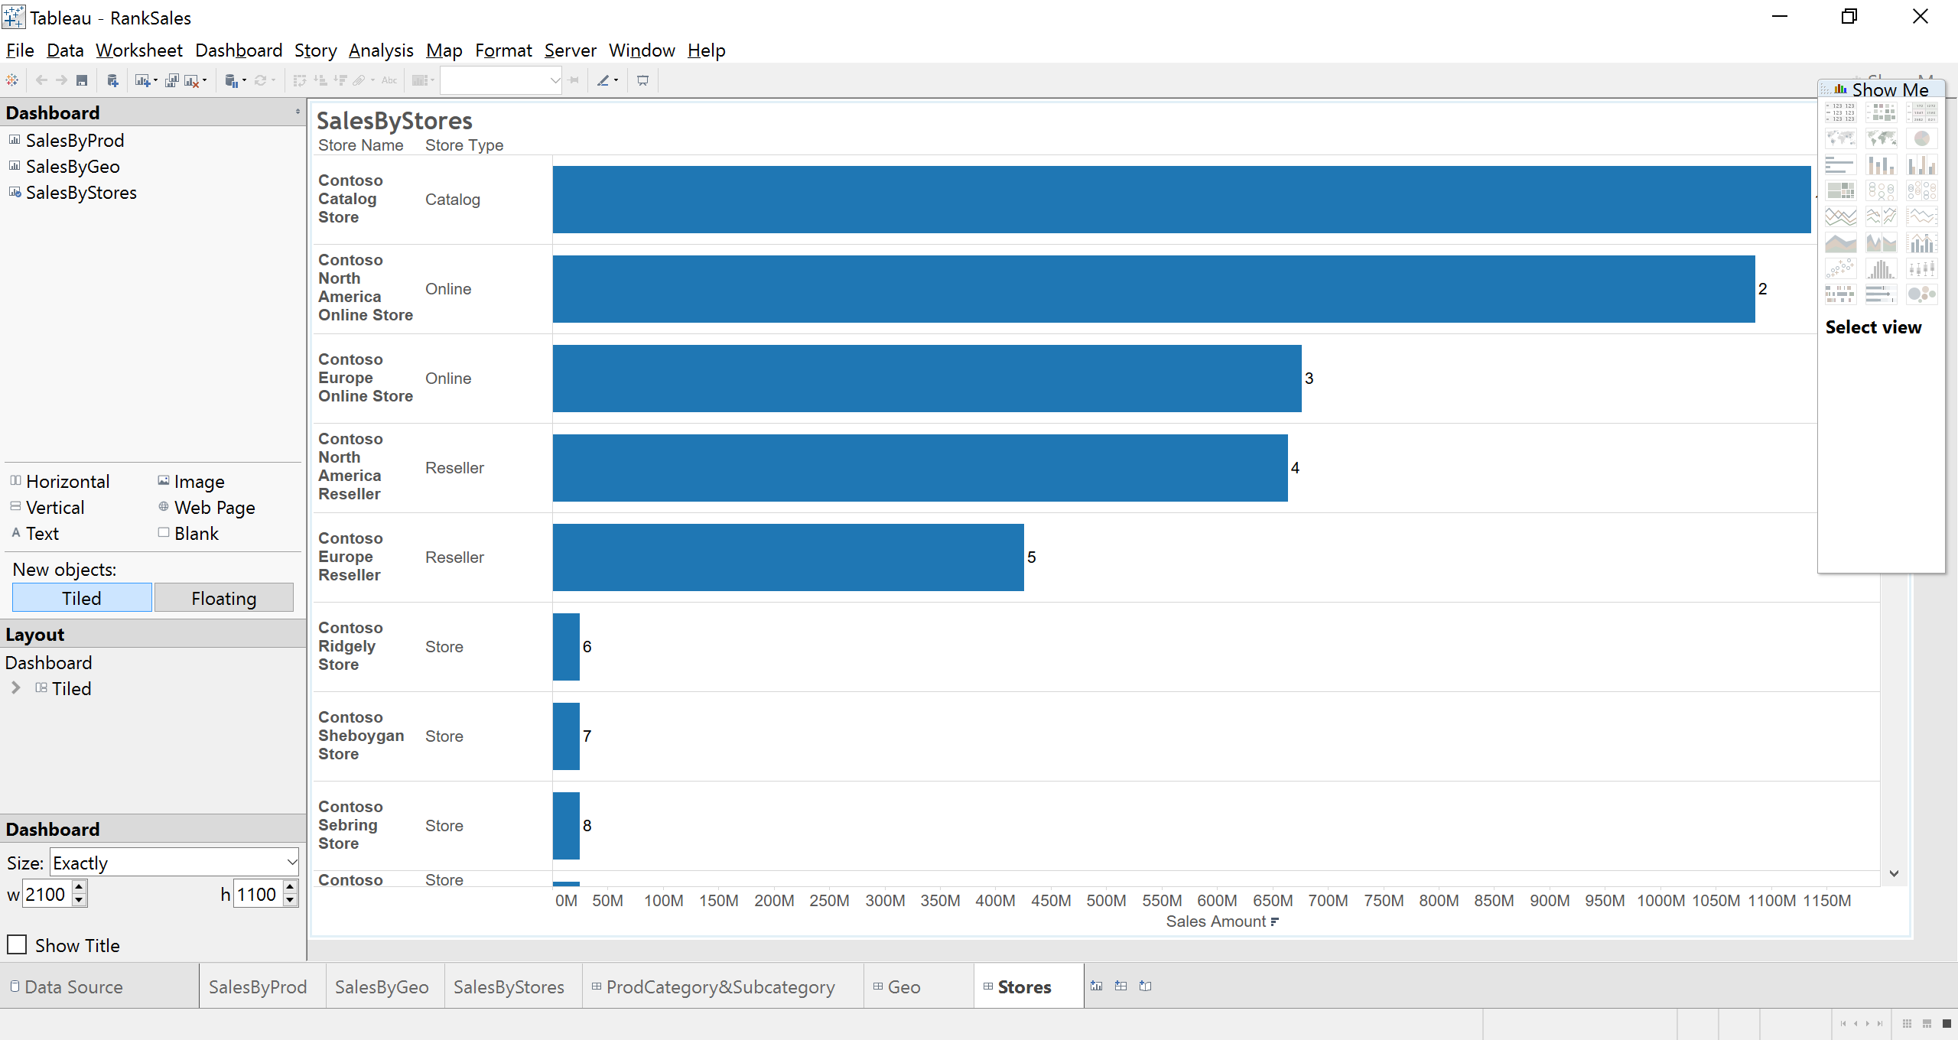

**Contribution Analysis**

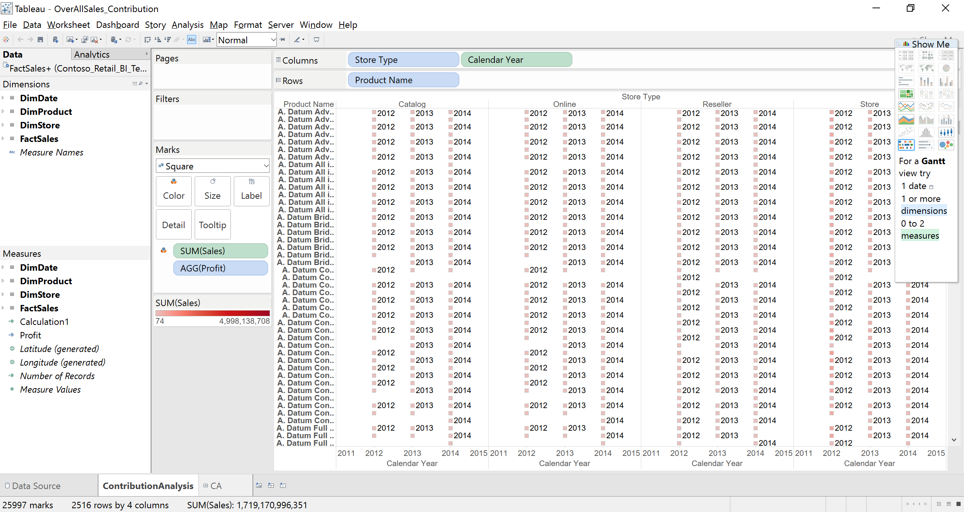

**GeoAnalysis**

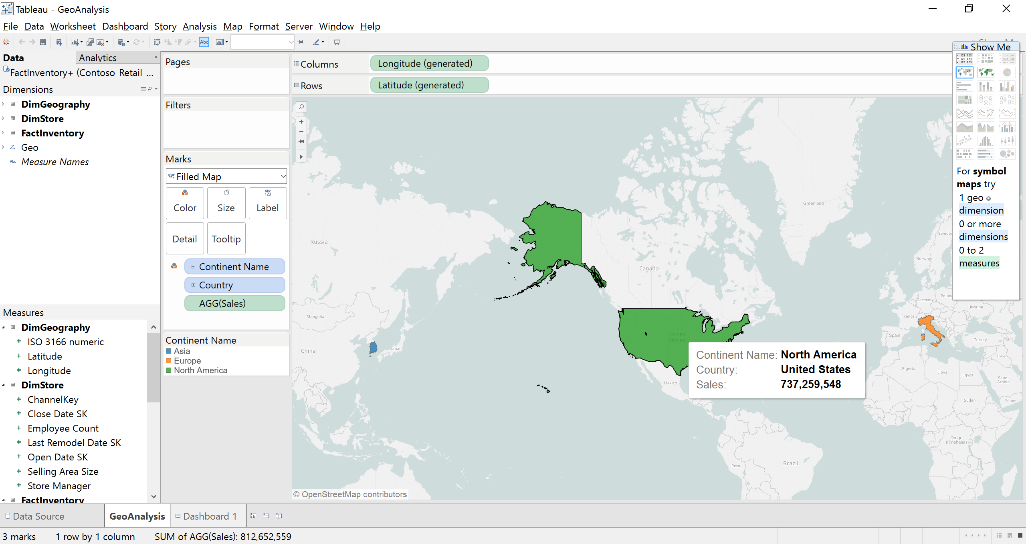

**Value Band Reporting**

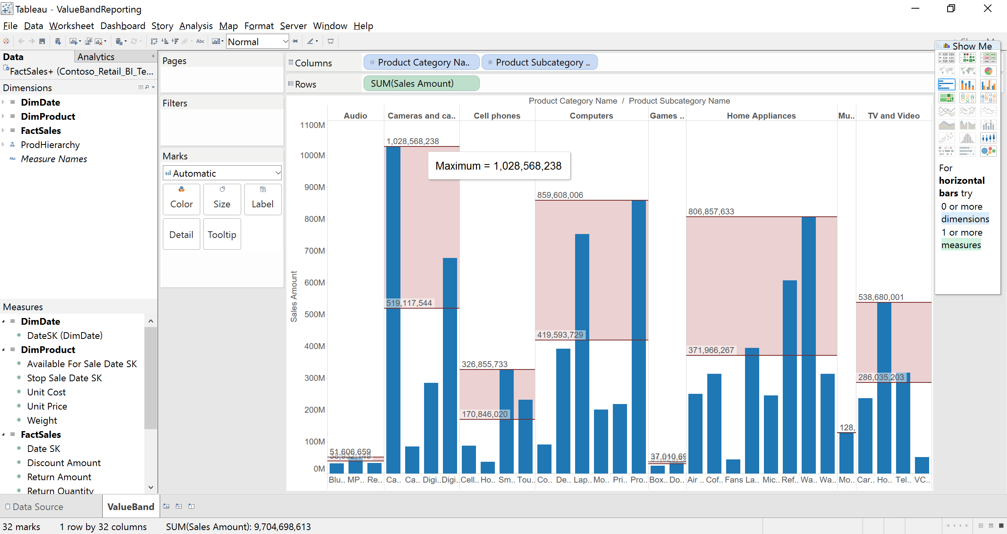

**--------------------Online Analysis--------------------------**

1. **Customer Demographics**

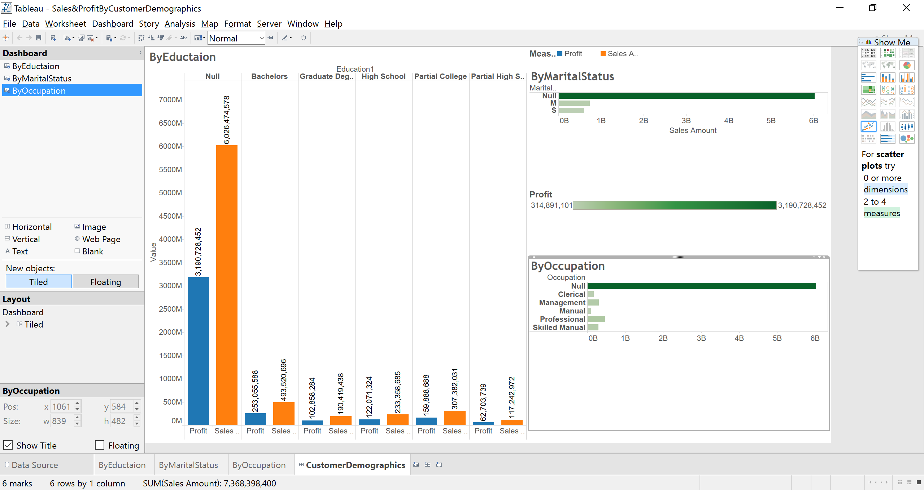

1. **Product Profit Margin based on promotion Type**

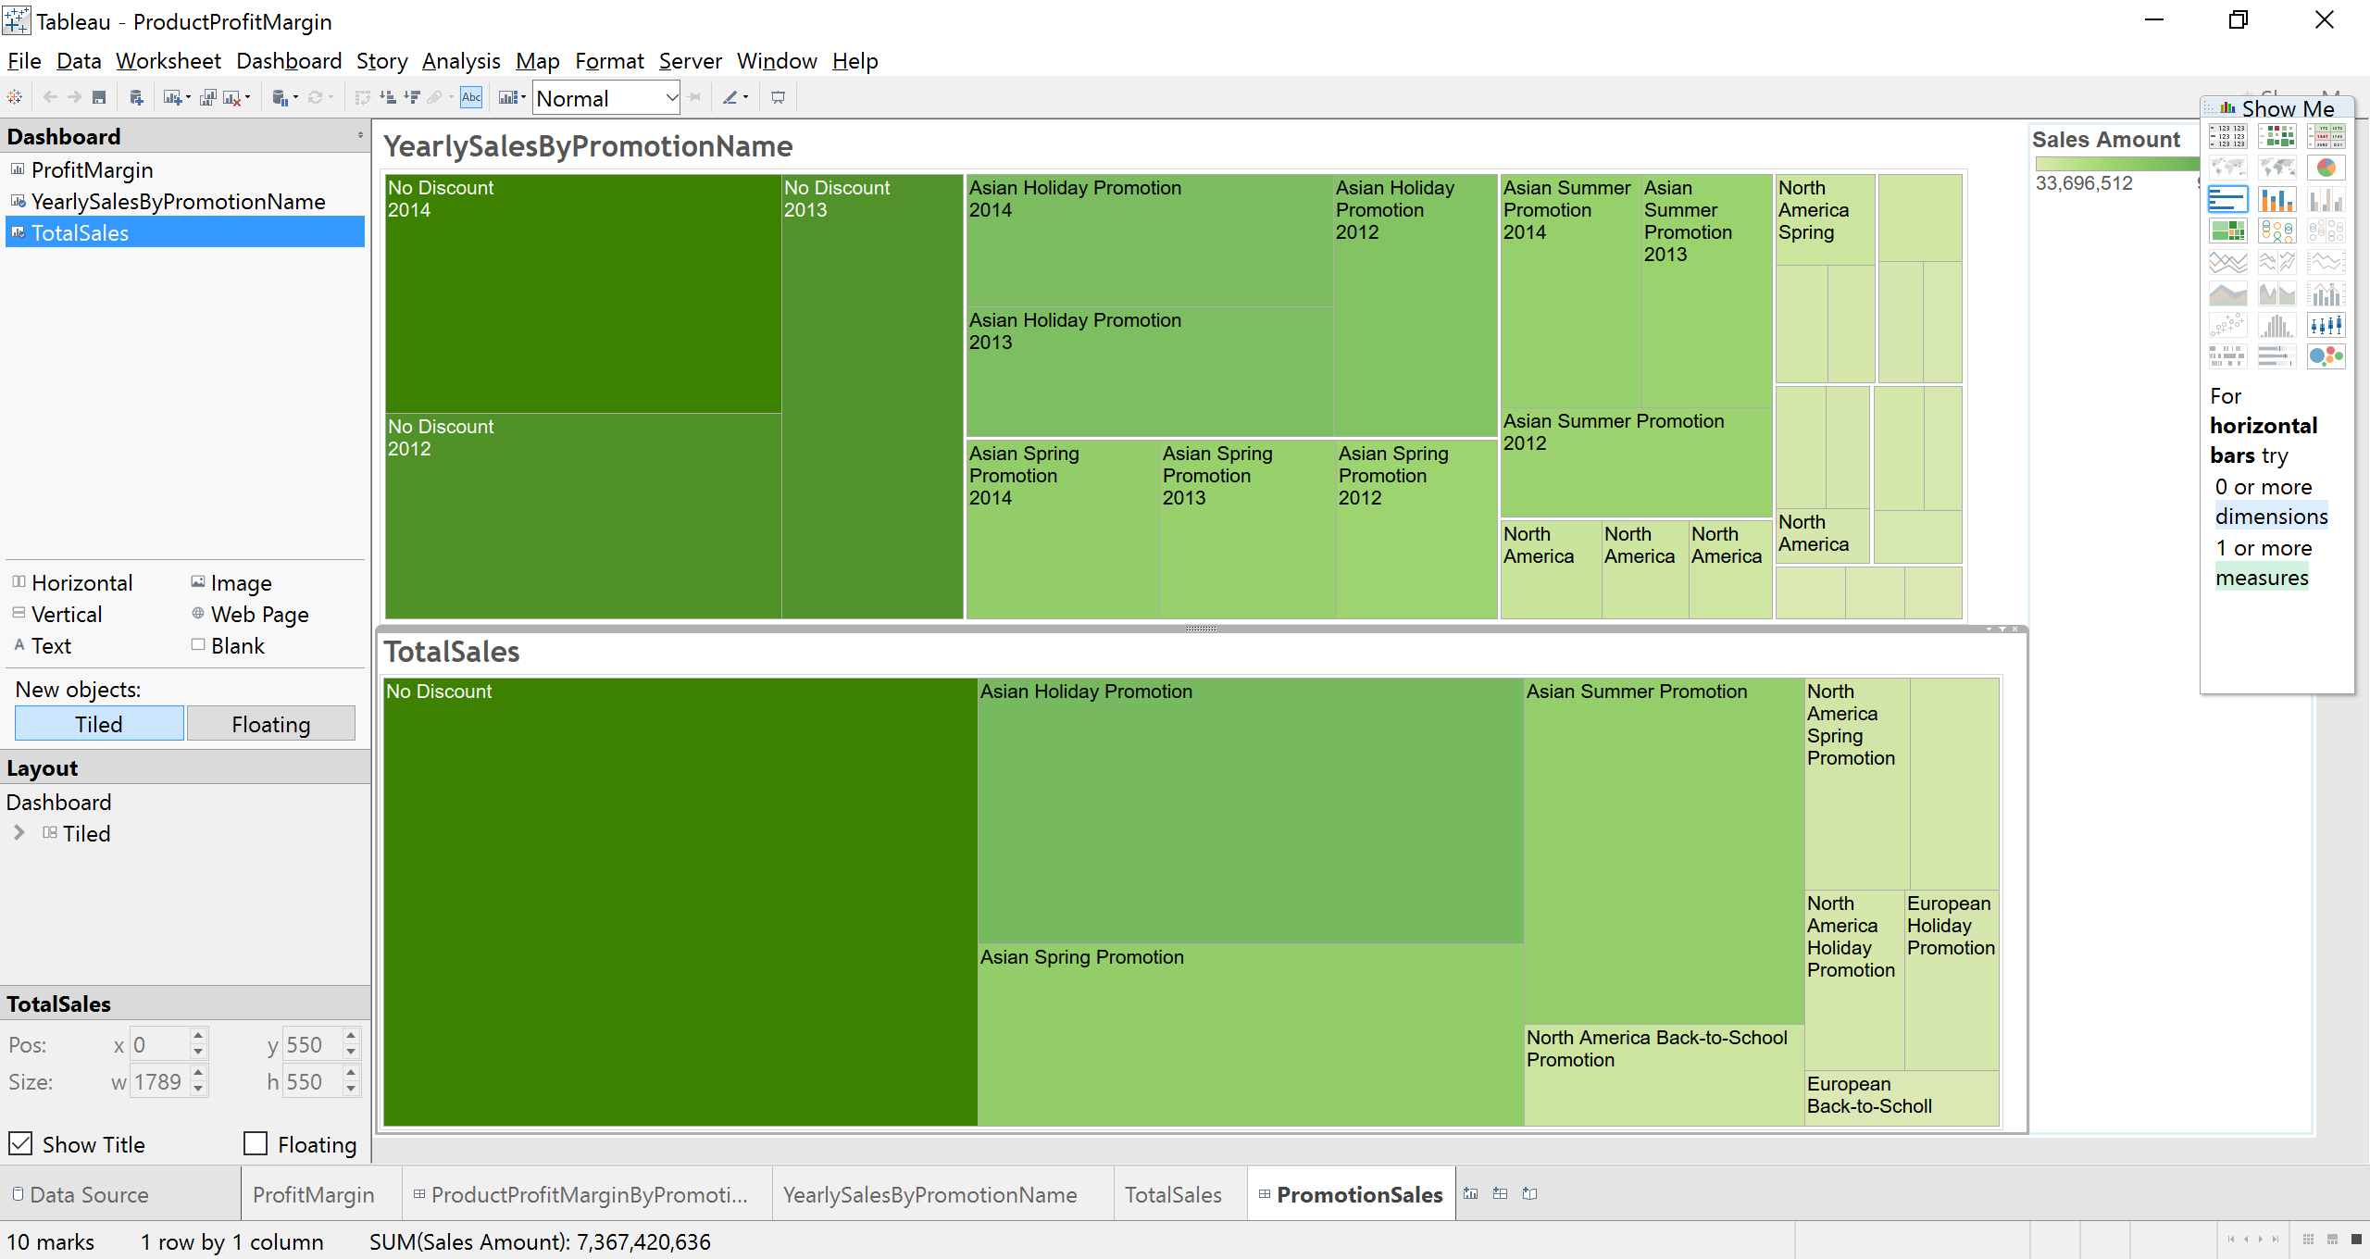

1. **Top Selling products**

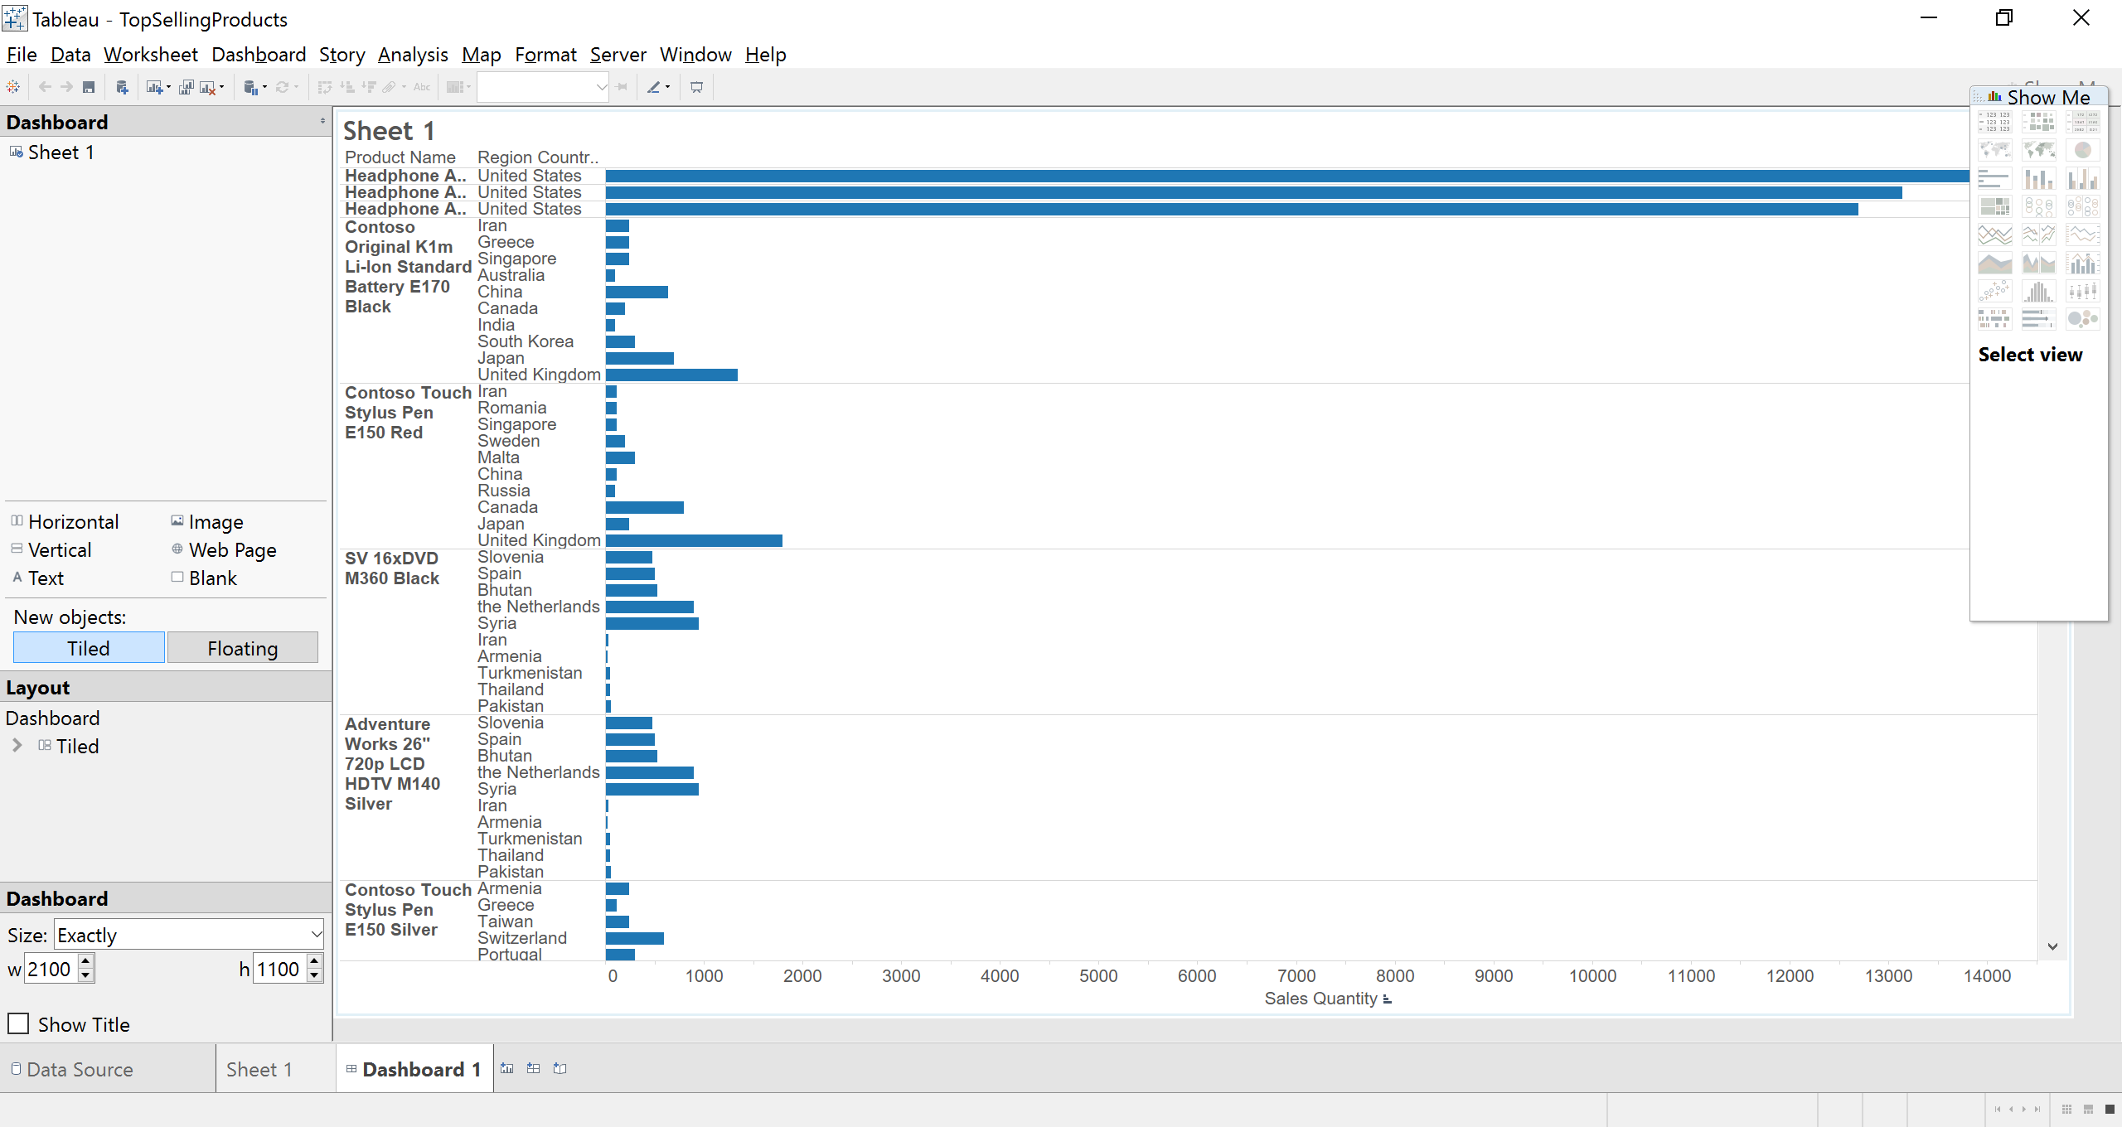

1. **Geo Analysis**

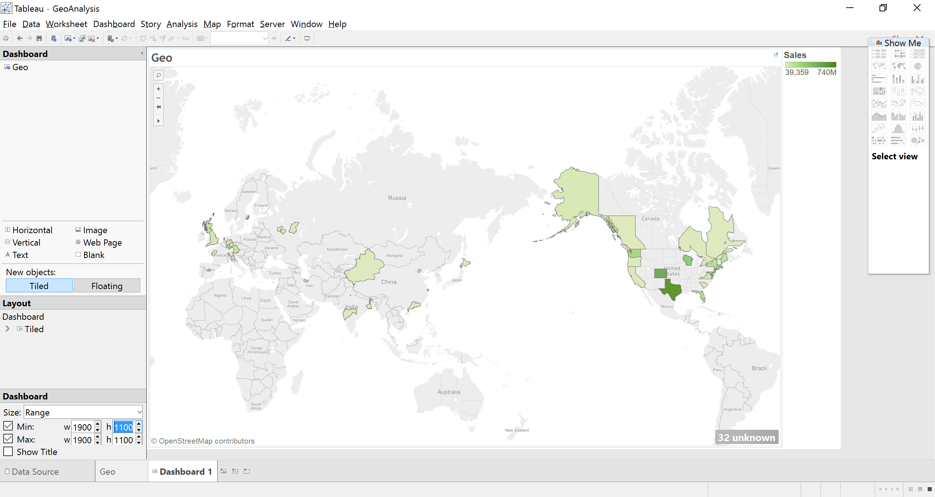

1. **PeriodOverPeriod Analysis**

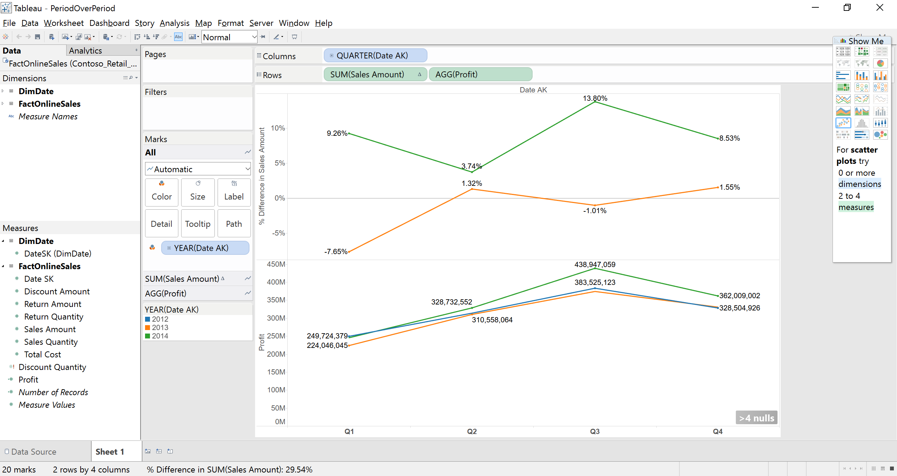

**-------Inventory Analysis-------------**

**InventoryCosts**

**By channel and Time**

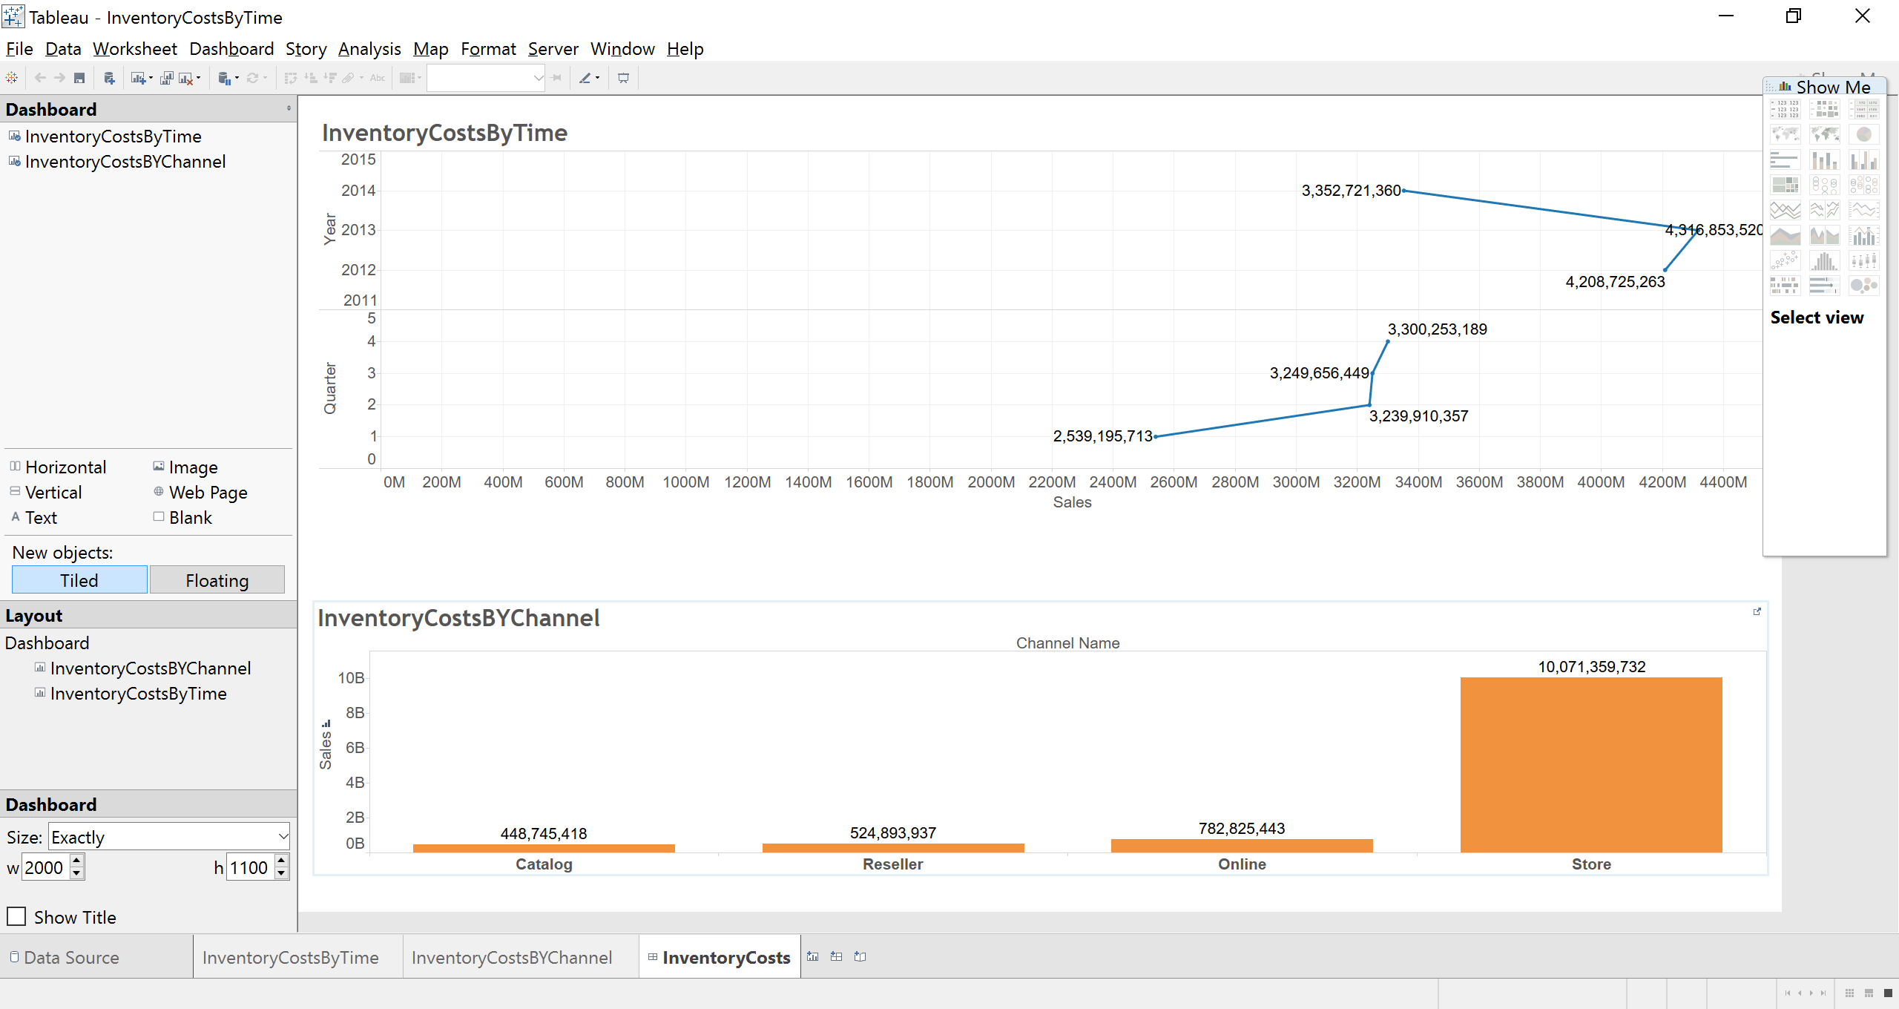

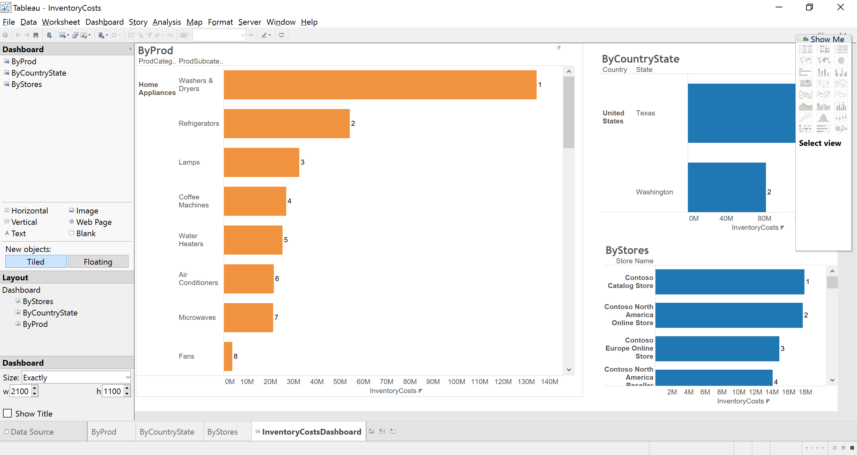

**Geo Analysis**

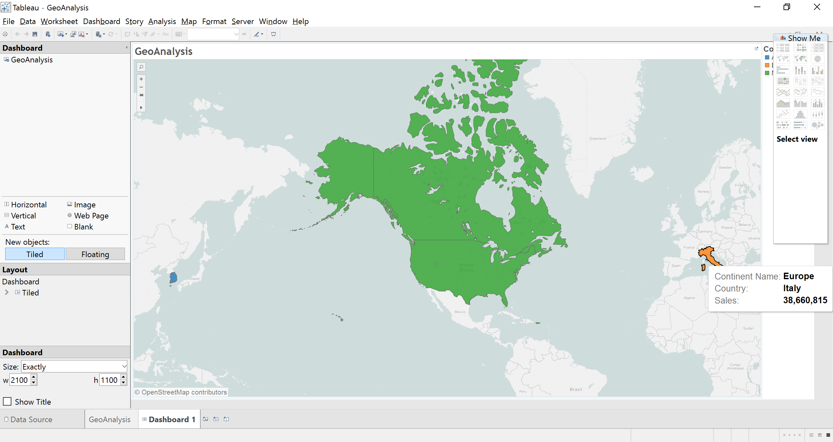

**ContriBution Analysis**

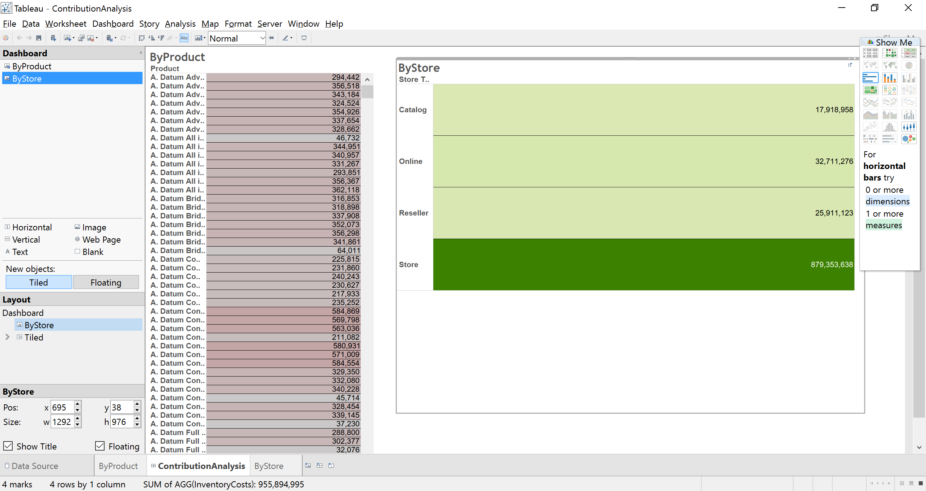

**QLIK: OverALL Sales**

**SalesByStore**

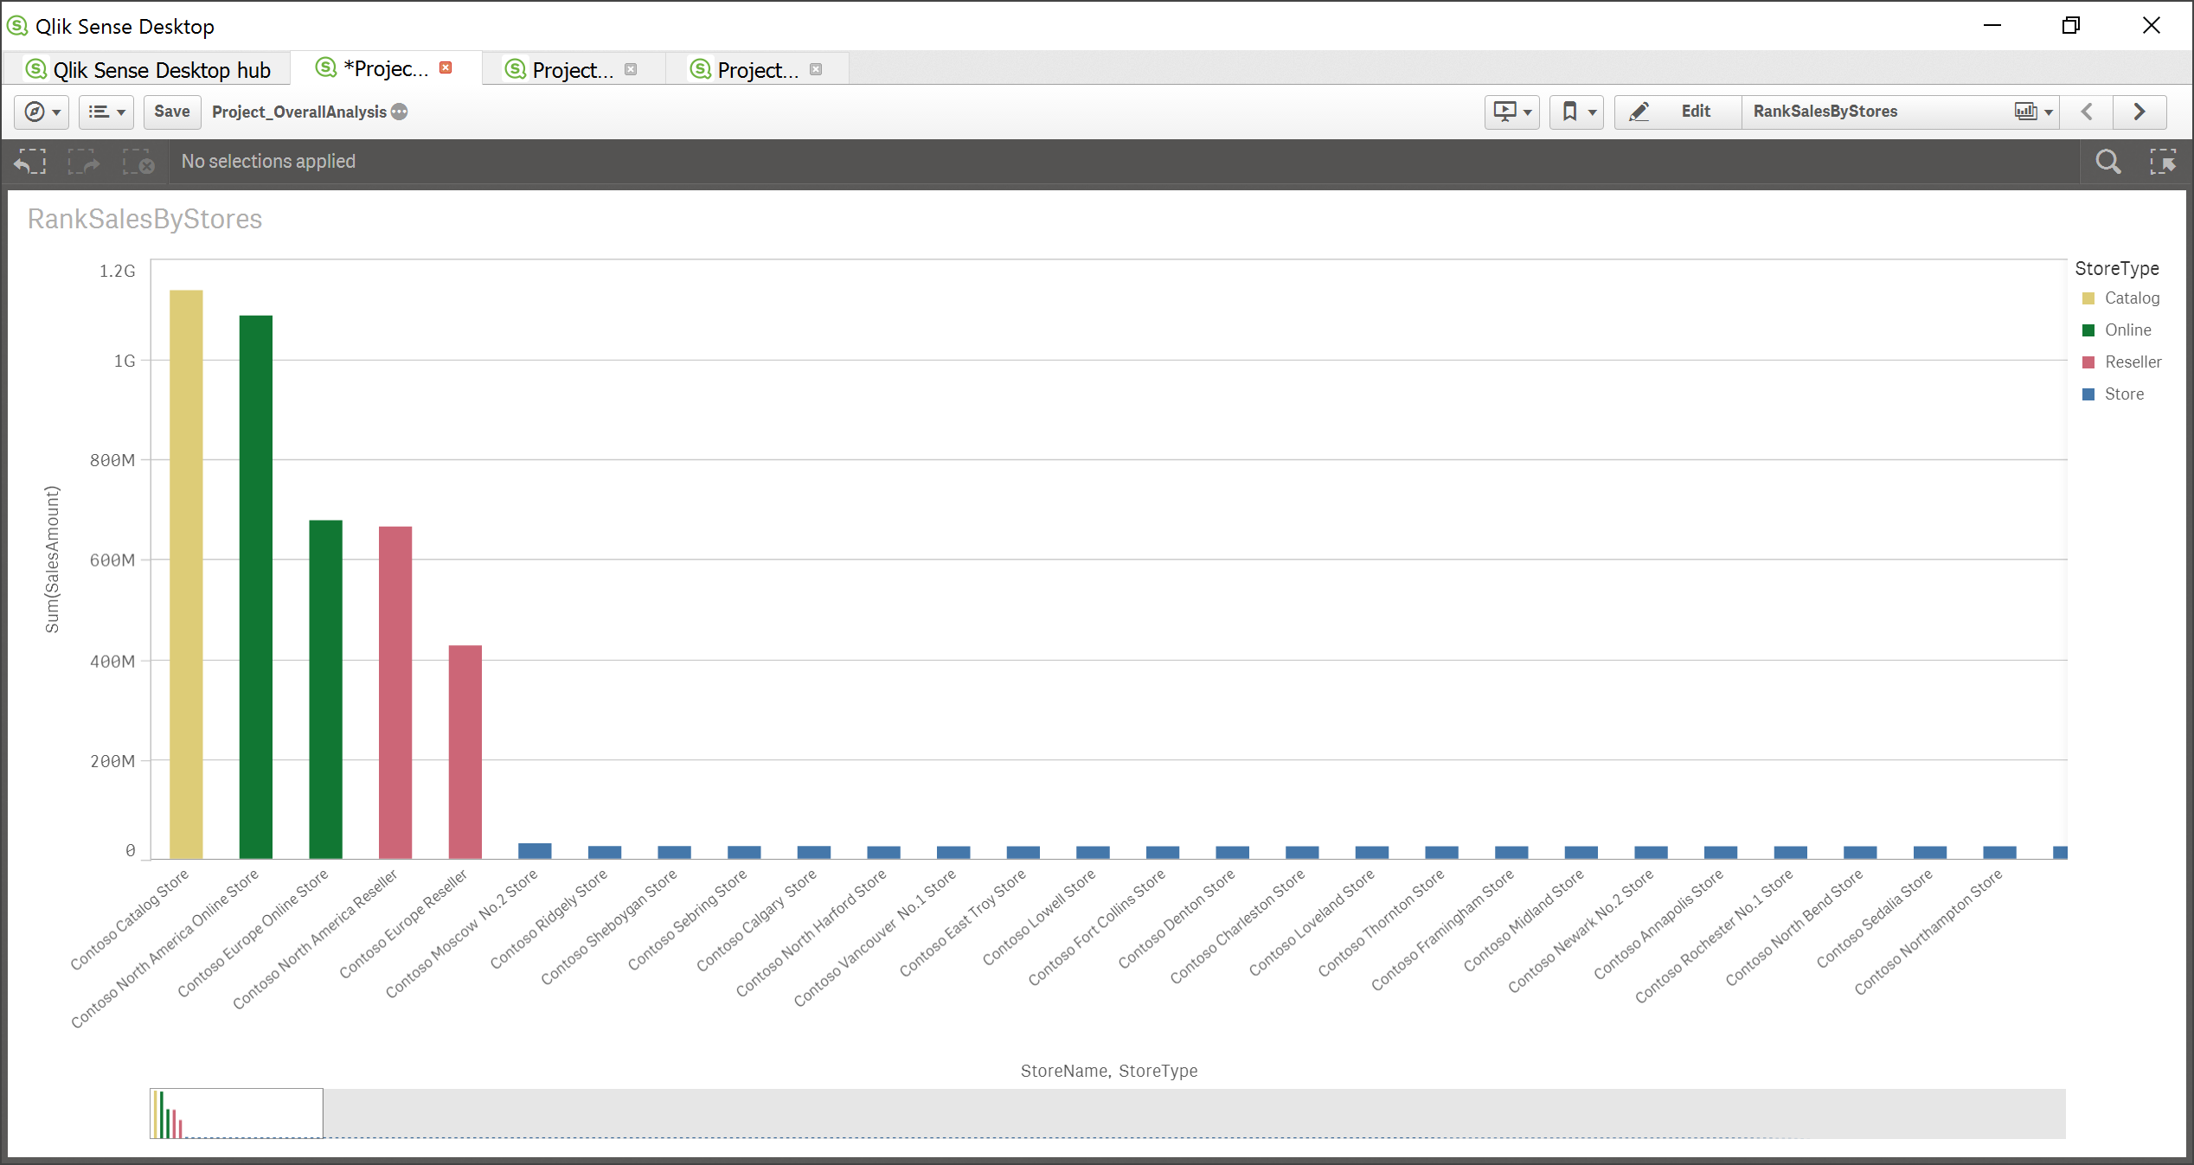

**Channel And Time**

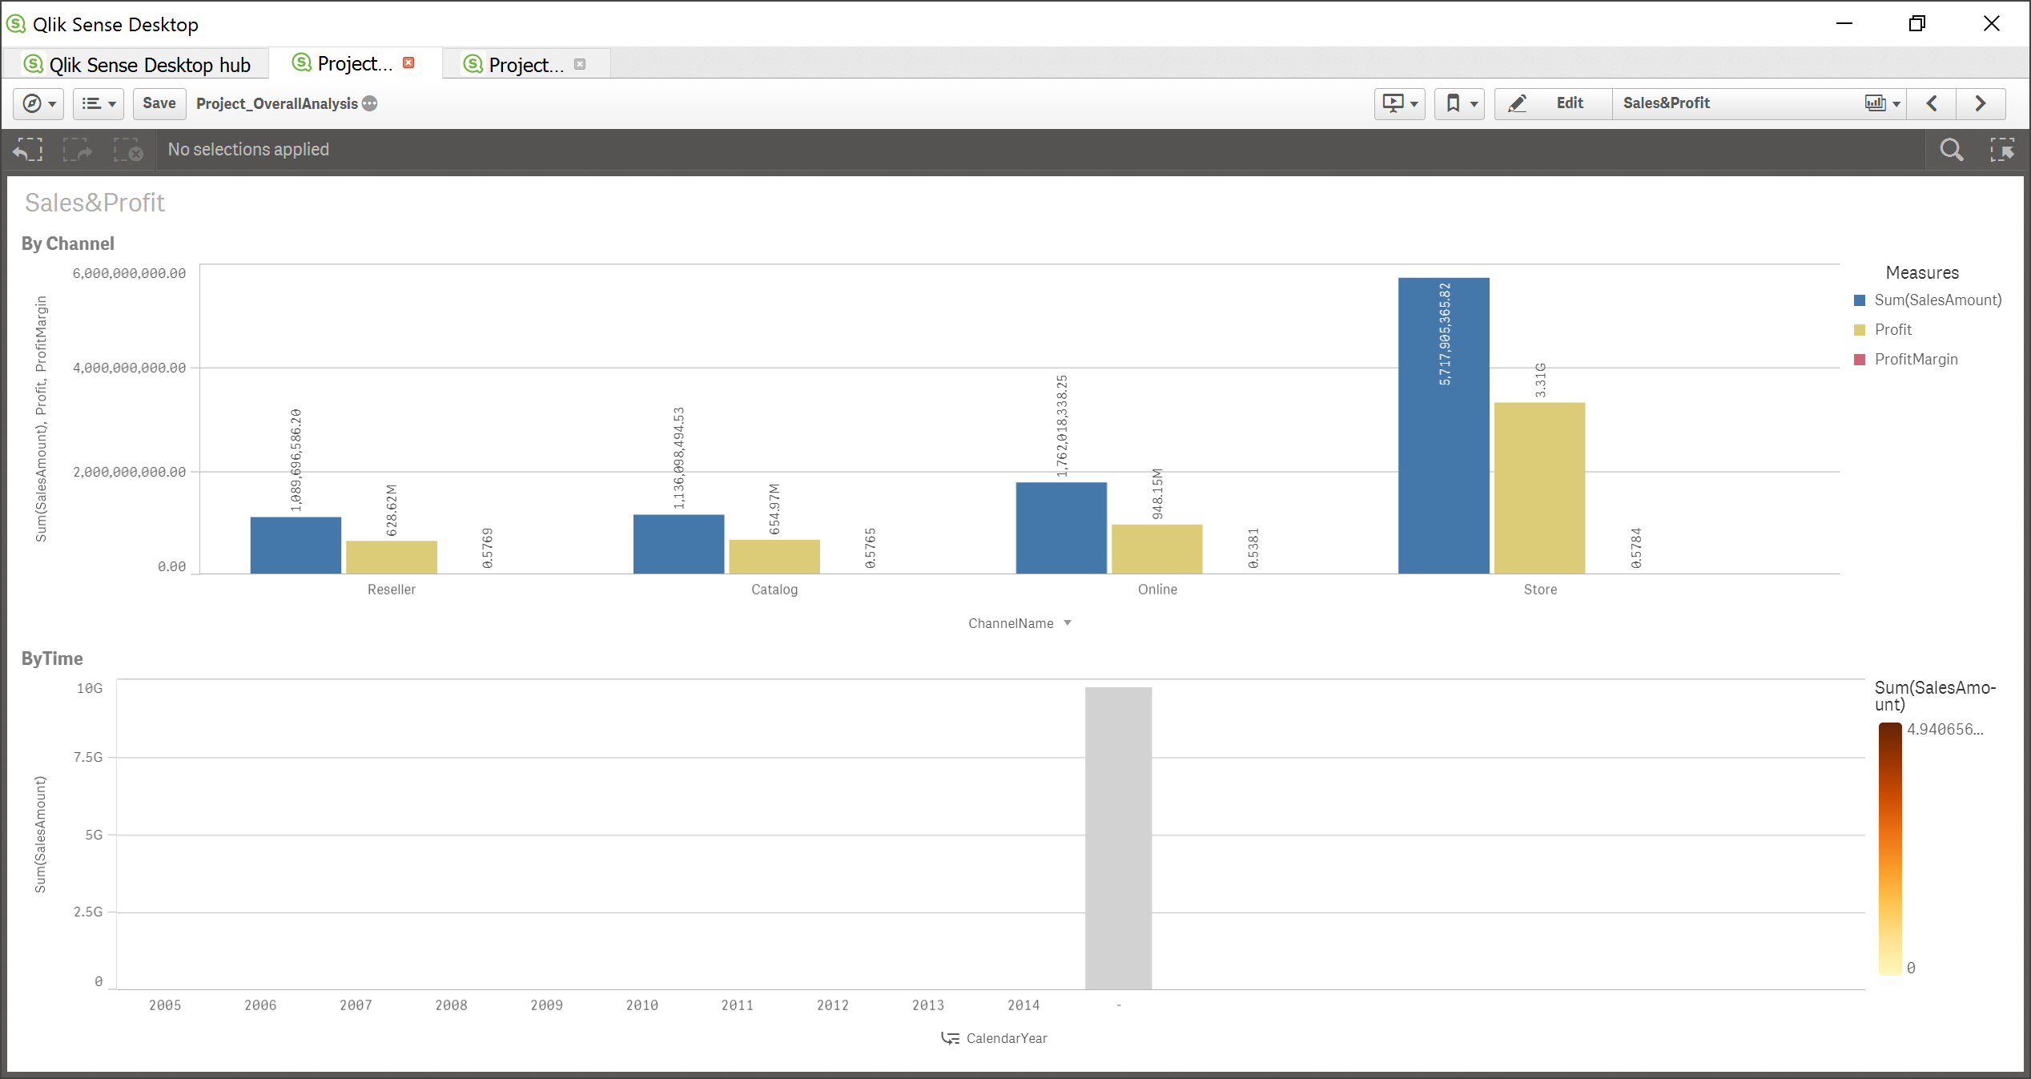

**By ProductCategory & SubCategory**

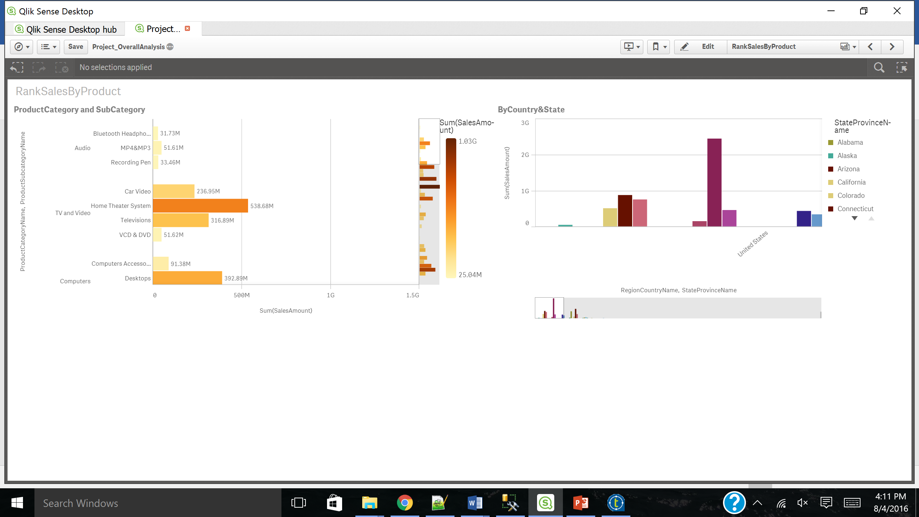

**Contribution Analysis**

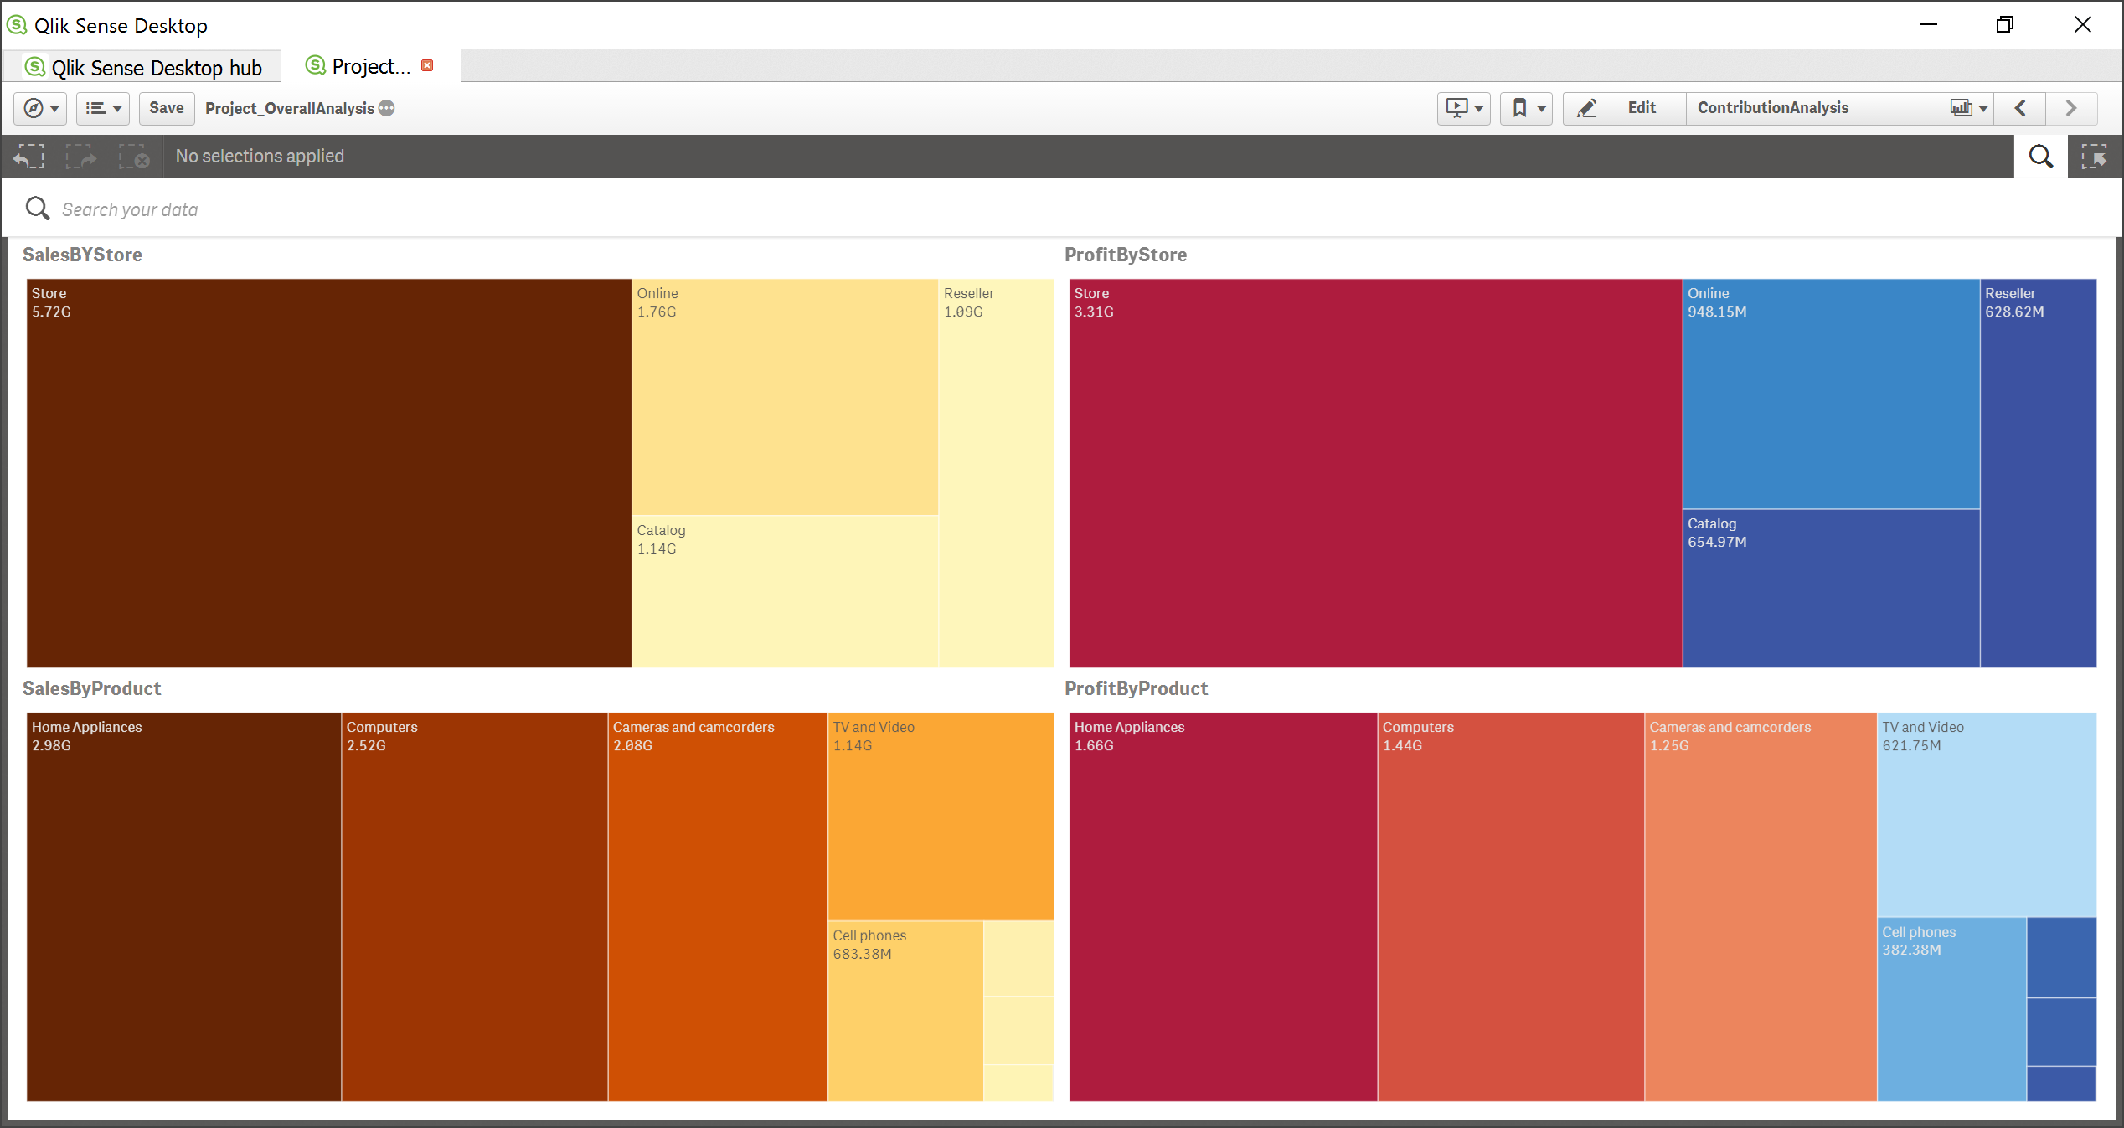

**---Online Sales---**

1. **Customer Demographics**

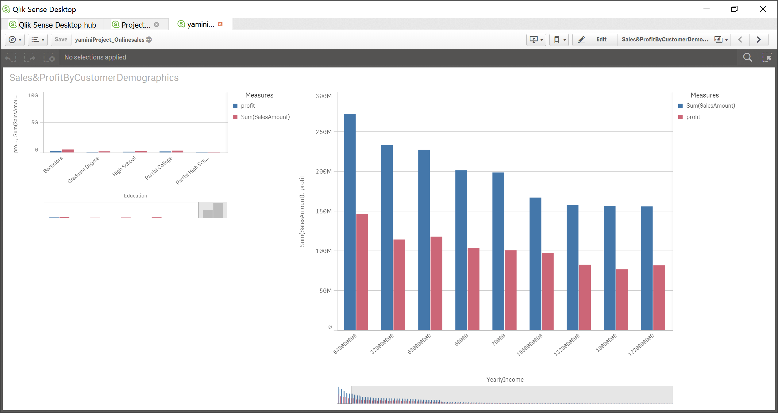

1. **PeriodOverPeriod**

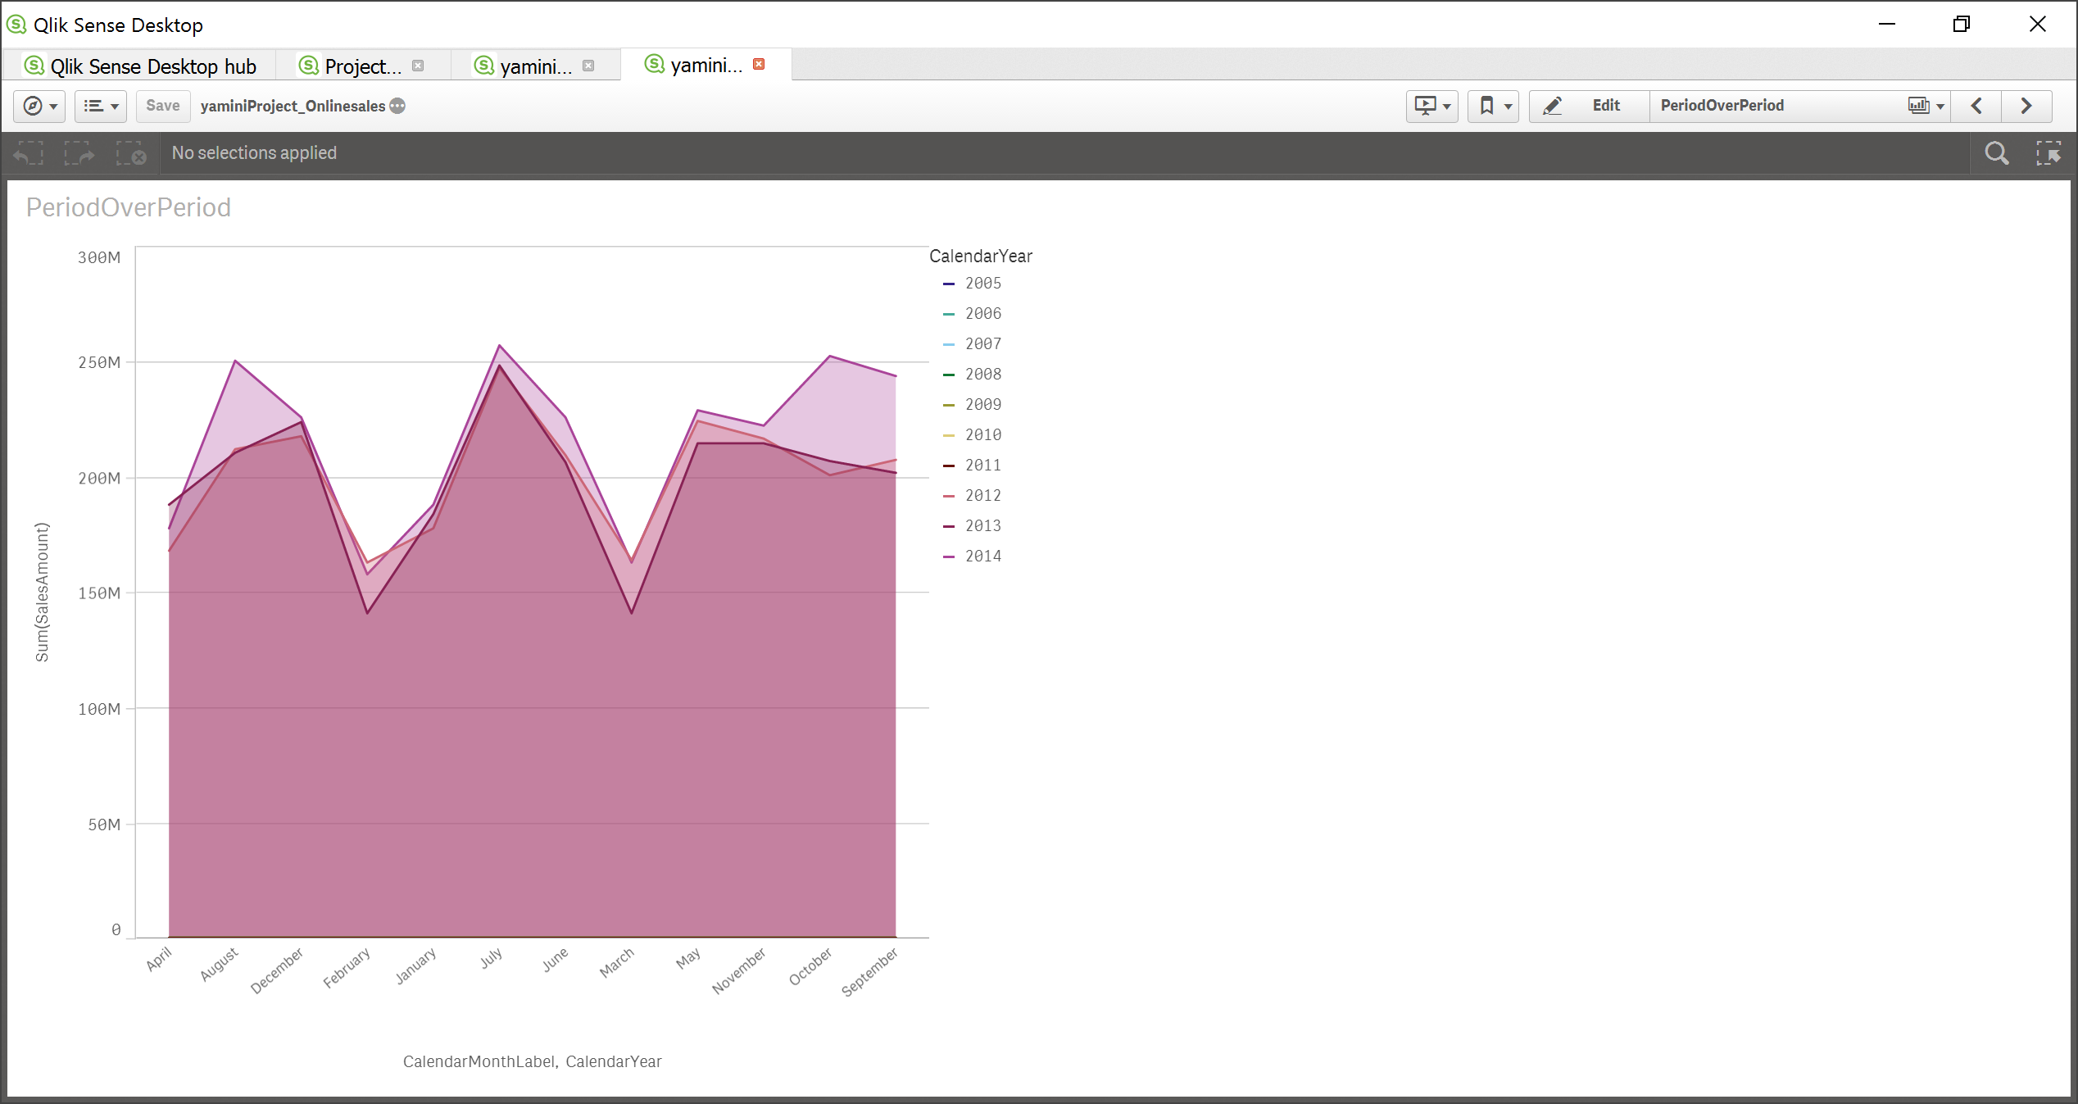

**Top Customer**

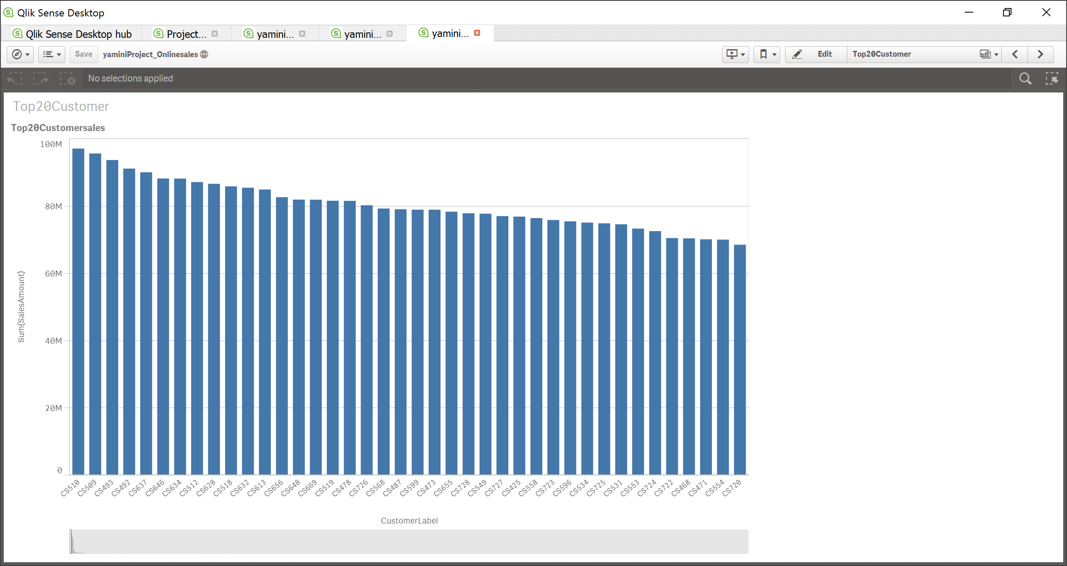

**Contribution Analysis**

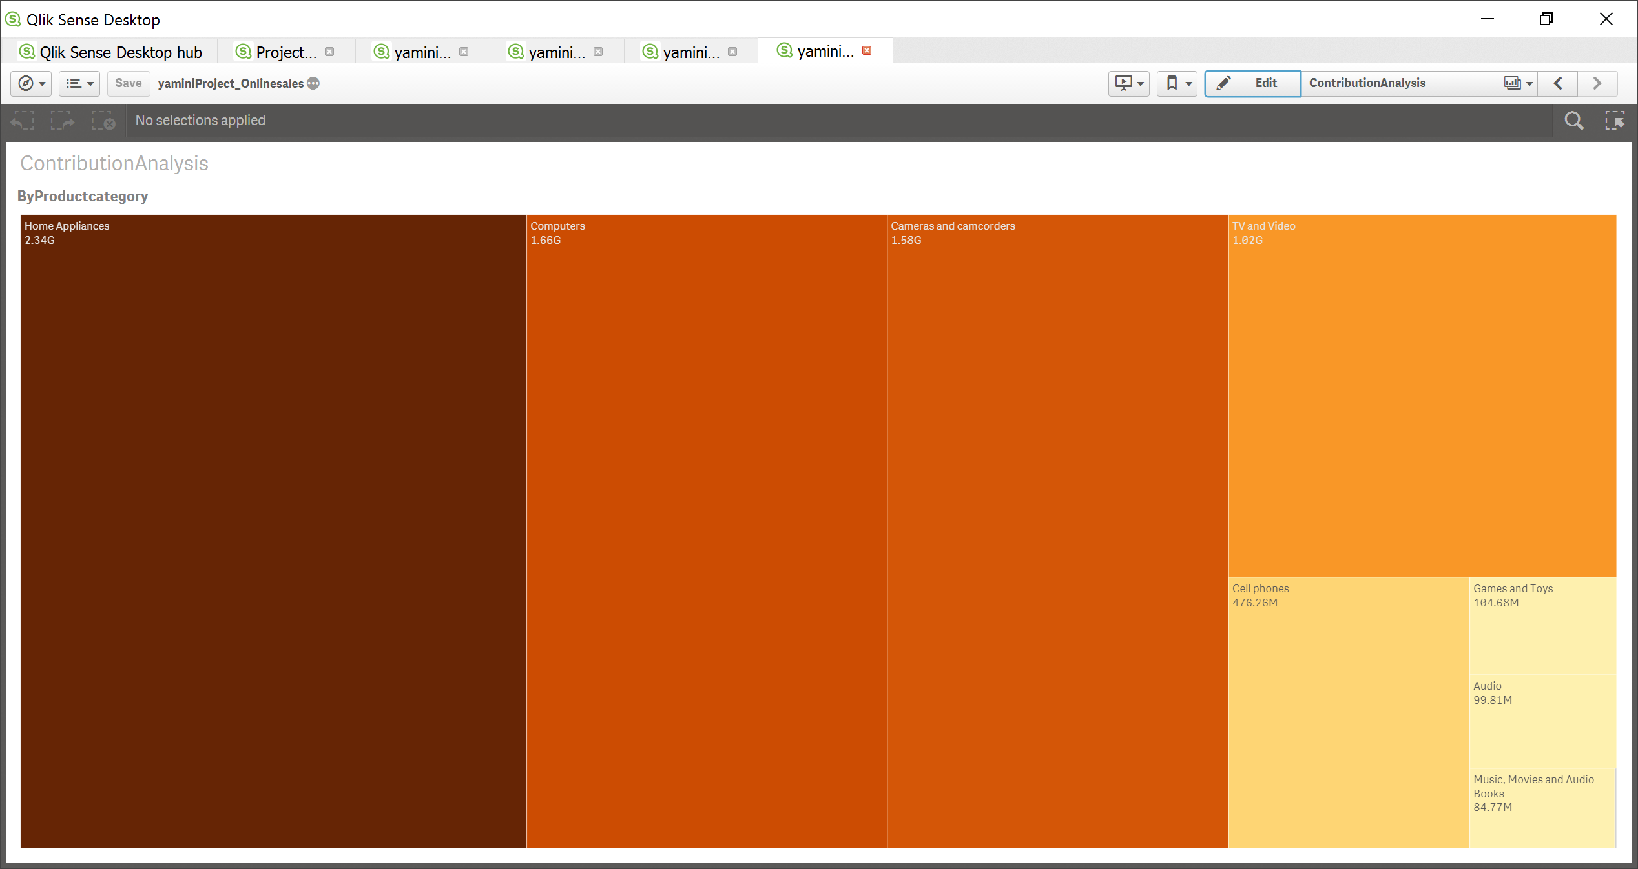

**-----------Inventory sales**

